** SHRI SHANKARACHARYA INSTITUTE OF PROFESSIONAL**

**MANAGEMENT AND TECHNOLOGY, RAIPUR**

**DEPARTMENT OF ELECTRONICS & TELECOMMUNICATION**

**B.Tech. VI SEMESTER**

**MINOR PROJECT SYNOPSIS**

**LEAF DISEASE DETECTION USING PYTHON**

1. **PERSONAL DETAIL :-**

Name - Harsh Thakur

Roll No. - 303302819027

Email ID – [harsh.thakur@ssipmt.com](mailto:harsh.thakur@ssipmt.com)

Contact No. - 7987738583

1. **PROJECT INFORMATION :-**

PROJECT TITLE – Leaf Disease Detection Using Python

SUBJECT AREA - Python

TYPE OF PROJECT - Software

1. **PROJECT SUMMARY:-**

**INTRODUCTION:** The existing methodology for disease detection is a just optic observation by specialists through that identification and detection of plant diseases is completed. Fordoing thus, an oversized team of specialists still as continuous watching of specialists are needed, that prices terribly high once farms are massive. At an equivalent time, in some countries, farmers don’t have correct facilities or maybe concept that they’ll contact specialists.

Because of that consulting specialists even price high still as time overwhelming too. In such condition, the advised technique proves to be helpful in watching massive fields of crops. And automatic detection of the diseases by simply seeing the symptoms on the plant leaves makes it easier still as cheaper.

1. **WORKING PRINCIPLE :-**

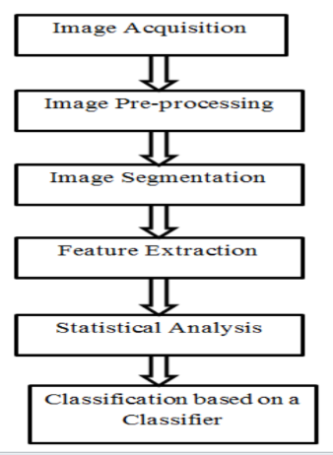**ARCHITECTURE:**



In this part, we explain the expectation of leaf malady utilizing a k-mean grouping calculation. This program remembers various measures for Image Acquisition, Image Preprocessing, Feature Extraction and the neural system based order. This goes about as pursues:

• Image Acquisition

• Image Preprocessing

• Image segmentation

• Feature extraction

**IMAGE ACQUISITION :** Plant leaf pictures are caught utilizing camera. Capturing of an image through image sensor is called image acquisition. The captured is in the form of RGB color model(Red, Green, Blue).The captured image should be transformed to reduce the number of gray levels.

**IMAGE PREPROCESSING :**  As the photographs are taken from the real field, they can contain soil, spores and water spots since clamor. The point of pre-handling information is to evacuate the commotion in the picture in order to change the pixel values. This expands the picture's exhibition.

**IMAGE SEGMENTATION:** Picture division is the third step of our proposed technique. The sectioned items were grouped into various parts utilizing the Otsu classifier and the k-mean bunch calculation. The RGB shading model is changed over into the shading model of the Lab before the pictures are grouped. The presentation of the Lab shading format is a simple method to group the fragmented edges.

**FEATURE EXTRACTION:** Component extraction is a type of dimension reduction that represents an object's interesting parts as a compact vector component. This technique becomes helpful where picture dimensions are wide and a reduced depiction of features is needed to easily complete tasks such as object matching and retrieval.

1. **HARDWARE REQUIREMENT:-**

Processor : Standard processor with a speed of 1.6 GHz or more

RAM : 256 MB RAM or more

Hard Disk : 2 GB or more

Monitor : Standard colour monitor

Keyboard : Standard keyboard

Mouse : Standard mouse

1. **SOFTWAREREQUIREMENT:-**

Operating System :      Windows, Linux, MacOS

User interface  :      Python,

Database             :      MySQL

Documentation Tool   :       Ms Office

## ****7.ADVANTAGES :-****

* High Accuracy
* Low complexity
* Detection of images been classified without any noise

## 8.APPLICATIONS

* Bio-Farm
* Bio-Pesticides

## ****9.FUTURE ENHANCEMENT****

To improve recognition rate in classification process Artificial Neural Network, Bayes classifier, Fuzzy Logic, and hybrid algorithms can also be used.

## ****10.CONCLUSION****

This program gives the executed results on different diseases classification techniques that can be used for plant leaf disease detection and an algorithm for image segmentation technique used for Automatic detection as well as classification of plant leaf diseases has been described later. Banana, beans, jackfruit, lemon, mango, potato, tomato, and sapota are some of those ten species on which proposed algorithm was tested. Therefore, related diseases for these plants were taken for identification. With very less computational efforts the optimum results were obtained, which also shows the efficiency of the proposed algorithm in recognition and classification of the leaf diseases. Another advantage of using this method is that the plant diseases can be identified at an early stage or the initial stage.

**REMARK BY PROJECT COORDINATOR:-**

**SIGN OF STUDENT SIGN OF PROJECT**

**COORDINATOR**

**SIGN OF HOD**